***QUANTITAVE ANALYSIS OF LOK SABHA ELECTION IN 2019***

**INTRODUTION:**

* 1. **Overview**

**The Lok Sabha, also known as the House of the People, is the lower house of India's Parliament. Here is an overview:**

**Composition: The Lok Sabha is composed of Members of Parliament (MPs) who are elected by the people of India. As of my last knowledge update in September 2021, there are 545 members, including two Anglo-Indian members nominated by the President of India. However, this number can change due to constitutional amendments.**

**Elections: Lok Sabha elections are held every five years, unless dissolved earlier. Members are elected through a direct and universal adult suffrage system. Each state and union territory is allocated a certain number of seats based on its population, and these seats are further divided into constituencies.**

**Powers and Functions: The Lok Sabha, along with the Rajya Sabha (the upper house), plays a crucial role in the legislative process of India. It is responsible for passing laws, scrutinizing and approving the budget, and representing the interests of the people.**

**Speaker: The Lok Sabha elects a Speaker from among its members. The Speaker is responsible for maintaining order during debates, deciding who may speak, and ensuring that parliamentary rules and procedures are followed.**

* 1. **Purpose of Lok Sabha Election:**

**The Lok Sabha, also known as the House of the People, is the lower house of India's Parliament. Here is an overview:**

**Composition: The Lok Sabha is composed of Members of Parliament (MPs) who are elected by the people of India. As of my last knowledge update in September 2021, there are 545 members, including two Anglo-Indian members nominated by the President of India. However, this number can change due to constitutional amendments.**

**Elections: Lok Sabha elections are held every five years, unless dissolved earlier. Members are elected through a direct and universal adult suffrage system. Each state and union territory is allocated a certain number of seats based on its population, and these seats are further divided into constituencies.**

**2 Problem Definition and Design Thinking:**

**2.1 Empathy Map:**

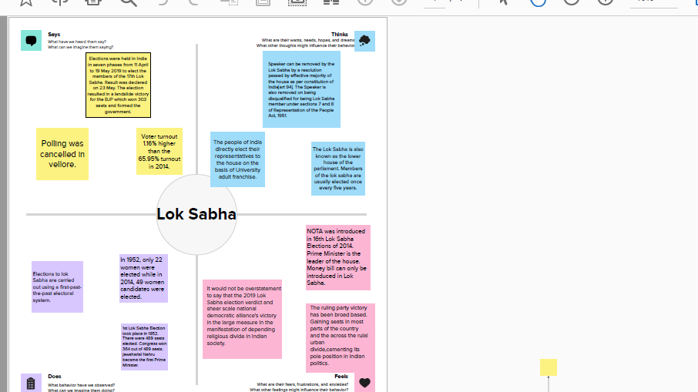

**2 Ideation and Brainstorming Map**

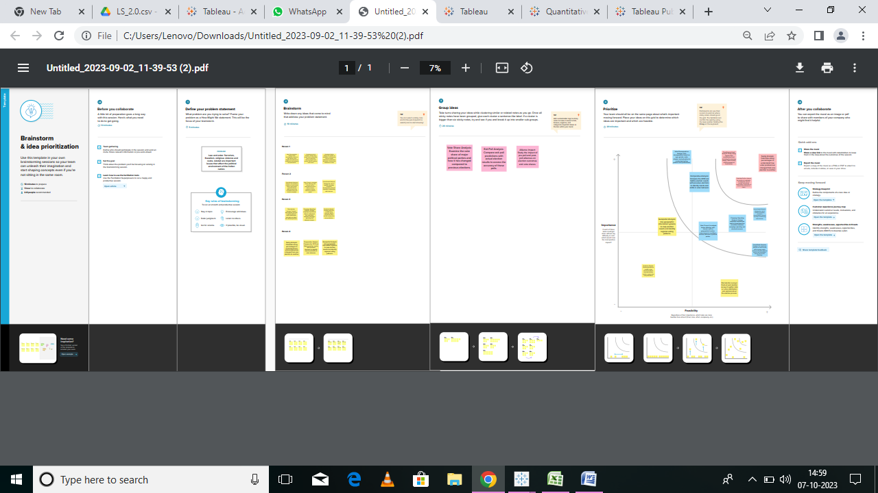

***Result***

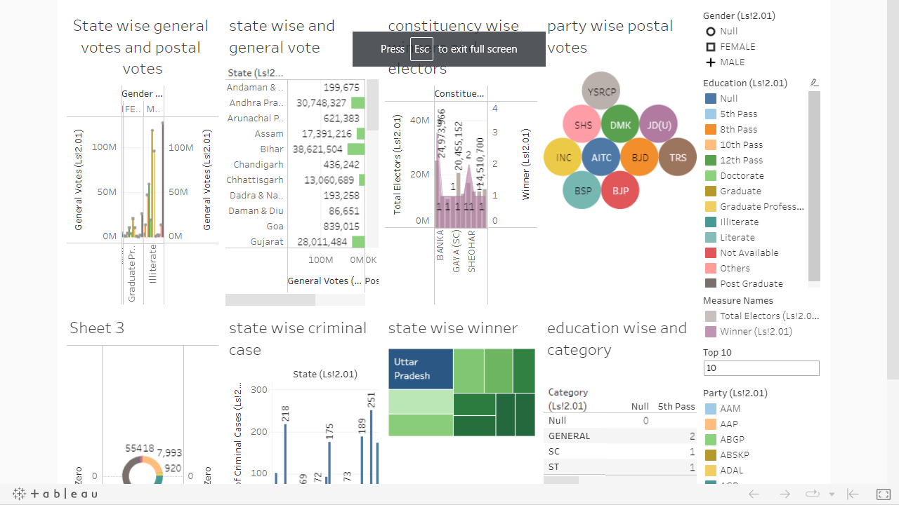

**4. Advantages and Disadvantages:**

**Democratic Representation: The Lok Sabha is the primary institution through which the people of India exercise their democratic right to elect their representatives. It ensures that the government is accountable to the people.**

**Legislative Function: The Lok Sabha plays a crucial role in the legislative process. It debates and passes laws that affect various aspects of Indian society, contributing to the development and progress of the country.**

**Diverse Representation: It provides representation to diverse segments of society, including different regions, communities, and interests. This ensures that a wide range of voices and perspectives are heard in the decision-making process.**

**Formation of Government: Lok Sabha elections determine the formation of the government. The majority party or coalition forms the executive branch, and its leader becomes the Prime Minister. This ensures stability and continuity in governance.**

**Check on Government: The Lok Sabha serves as a check on the government's actions. MPs can question the government, debate policies, and hold it accountable for its actions, promoting transparency and responsible governance.**

**Disadvantages:**

**Political Fragmentation: India's multi-party system can lead to political fragmentation. It often results in coalition governments, which can be less stable and effective in decision-making.**

**Disruption: Sometimes, the functioning of the Lok Sabha can be disrupted due to protests, walkouts, and other parliamentary tactics, which can hinder legislative work.**

**Lack of Adequate Representation: Despite efforts to ensure representation, there may still be groups and communities that are underrepresented or marginalized in the Lok Sabha.**

**Populist Policies: In an attempt to win elections, parties may sometimes focus on populist policies rather than long-term, sustainable solutions to issues.**

**Influence of Money and Muscle Power: Lok Sabha elections can be expensive affairs, and the influence of money and muscle power in politics can be a concern, potentially leading to corruption and unethical practices.**

**Gridlock: Political polarization and differences among parties can sometimes result in legislative gridlock, making it difficult to pass essential reforms and laws.**

**It's important to note that the advantages and disadvantages of the Lok Sabha can vary depending on the perspective of different individuals and the specific context of each election cycle. Additionally, efforts are continually made to address some of the disadvantages and improve the functioning of India's parliamentary system.**

**5 *APPLICATION***

**Elections: Lok Sabha elections are held every five years, unless dissolved earlier. Members are elected through a direct and universal adult suffrage system. Each state and union territory is allocated a certain number of seats based on its population, and these seats are further divided into constituencies.**

**Powers and Functions: The Lok Sabha, along with the Rajya Sabha (the upper house), plays a crucial role in the legislative process of India. It is responsible for passing laws, scrutinizing and approving the budget, and representing the interests of the people.**

**Speaker: The Lok Sabha elects a Speaker from among its members. The Speaker is responsible for maintaining order during debates, deciding who may speak, and ensuring that parliamentary rules and procedures are followed.**

**Sessions: The Lok Sabha typically meets for three sessions in a year—Budget Session, Monsoon Session, and Winter Session. Special sessions can also be convened if needed.**

**Committees: Various committees are formed within the Lok Sabha to examine specific issues, review bills, and provide recommendations. Some of the prominent committees include the Public Accounts Committee (PAC) and the Committee on Public Undertakings.**

**Role in Government Formation: The political party or coalition with a majority in the Lok Sabha forms the government, and its leader becomes the Prime Minister of India.**

**Accountability: MPs in the Lok Sabha are accountable to their constituents, and they represent the interests and concerns of the people in the legislature.**

**Please note that there may have been developments or changes since my last update in September 2021, so it's advisable to refer to the latest sources for the most current information regarding the Lok Sabha.**

**The Lok Sabha elections in India serve several important purposes:**

**Democratic Representation: Lok Sabha elections are the means through which the people of India exercise their democratic right to elect their representatives. This is a fundamental aspect of a democratic system, allowing citizens to have a say in the governance of the country.**

**Formation of Government: The party or coalition that wins a majority of seats in the Lok Sabha forms the government. The leader of the majority party becomes the Prime Minister. Therefore, these elections determine the executive branch of the government.**

**Legislative Function: The Lok Sabha plays a crucial role in the legislative process. Elected members introduce, debate, and pass laws that affect various aspects of Indian society and governance. These laws can range from economic policies to social issues.**

**Scrutiny of Government: The Lok Sabha acts as a check on the government's actions. Members of Parliament (MPs) can question the government, hold it accountable for its policies and actions, and demand explanations for decisions taken.**

**Representation of Diverse Interests: India is a diverse country with a wide range of social, economic, and cultural interests. Lok Sabha elections ensure that various segments of society are represented, and their concerns are brought to the forefront.**

**Policy Direction: The outcome of Lok Sabha elections often determines the direction of government policies. Different parties may have different ideologies and poli…**

**6 *CONCLUSION***

**The Lok Sabha is the lower house of India's Parliament, responsible for making and passing legislation. It represents the people of India, with members elected by eligible voters. The Lok Sabha plays a vital role in the democratic process, ensuring the government's accountability to the people. Its conclusions often involve the passage or rejection of bills, debates on important issues, and the formation of the government. The Lok Sabha's effectiveness in addressing the nation's challenges depends on the cooperation and decision-making of its members and the government.**